Robin Class Home Learning Activities
You can complete any of these activities between now and Half Term. Due date: 23rd May 2025

Design and build your own clock. | Research food that the Vikings would have eaten. Cook or bake something from that time. | Build a Viking long boat.  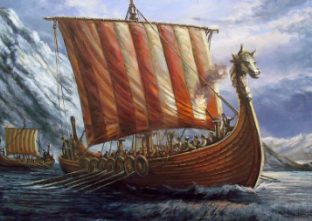
Create a Viking shield, helmet or weapon. | Create a painting of a Norse god or goddess. | Write a fact file about a Norse god or Goddess.

