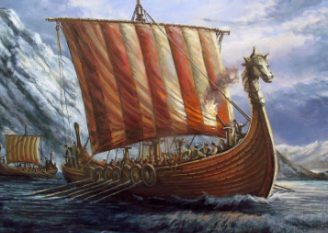
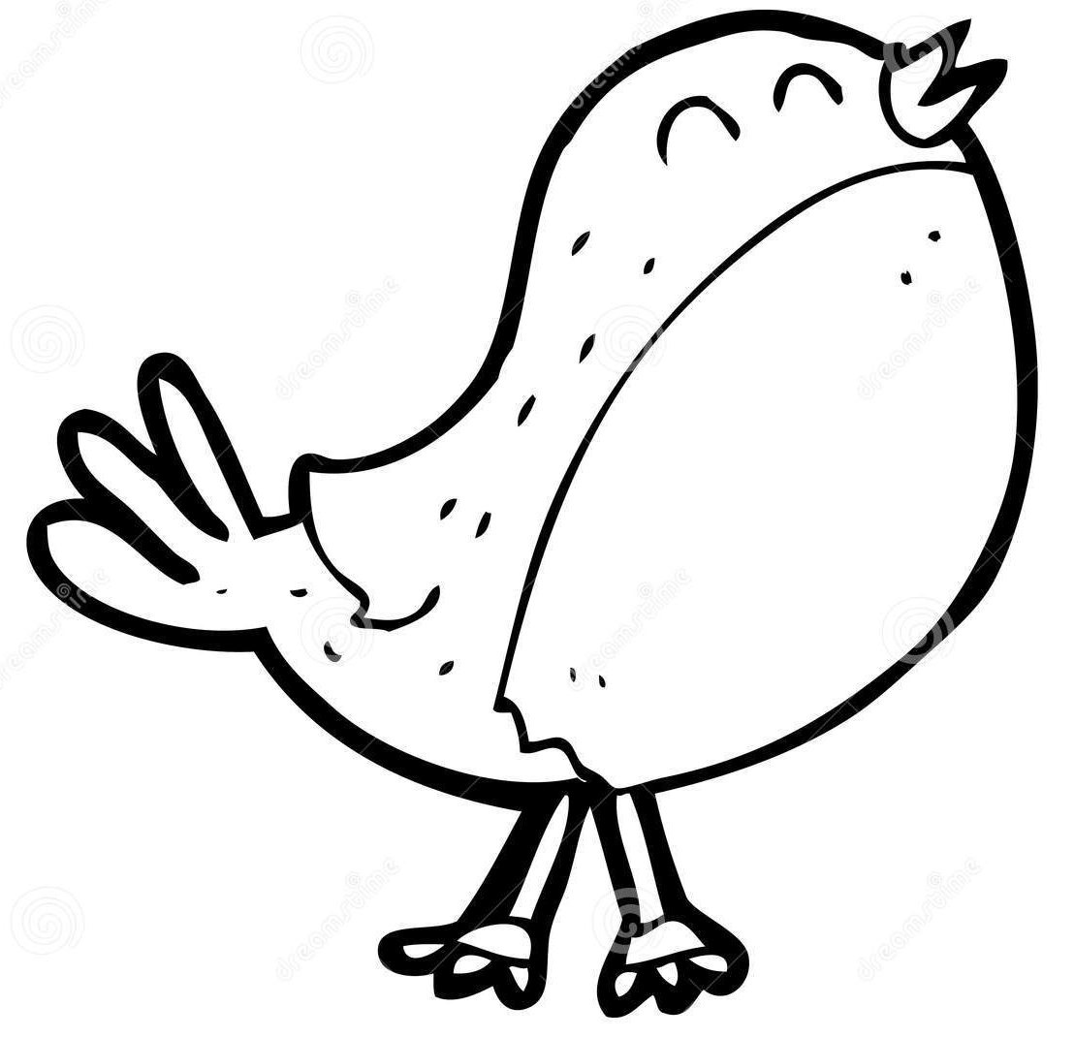
This term our topic in Robin Class is
Home Learning
- EdShed online spelling homework – practise daily
- Daily reading from reading book – minimum of four to be recorded in Reading Records every week.
- MyMaths activity or Maths homework sheet on class learning where relevant
- TT Rockstars practise
Using books and websites, do some research for one or more of the Activity Grid. Your work needs to be handed in on the Monday of the final week of May Half Term (Monday 23rd May).

‘Vikings’
Key Learning in History
Questions:
- Why did the Vikings raid and invade Britain?
- Who were the Norse gods?
- Why did Alfred sign the treaty with Guthrum?
- Was Alfred right to make a deal with the Vikings?
- What were the similarities and differences between Norse and Anglo-Saxon beliefs?

Other Key Learning
- PE: Athletics/ Gymnastics
- Music: Just three
- French: Clothes
- PSHE: Being my Best
- Art: Power prints
- RE: God talk in different traditions
- Computing: Branching databases
Key Learning
English:
- The Iron Man by Ted Hughes – To write and perform a monologue.
- The Barnabus Project by the Fan Brothers – Non-Chronological
Maths:
- Time – telling time o o’clock, half past, 5 minutes, 24hr, analogue and digital, durations, time in seconds, years, months and days.
- Decimals
- Money
- Shape
- Statistics
Key Learning in Science
The Digestive System:
- Carnivores, herbivores and omnivores
- Human teeth and the layers
- Tooth decay
- The digestive system
Class Books: Viking Boy by Tony Bradman
Robin Class Trip
Viking’s at Ufton Court 1st May.

