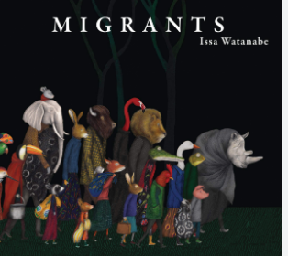
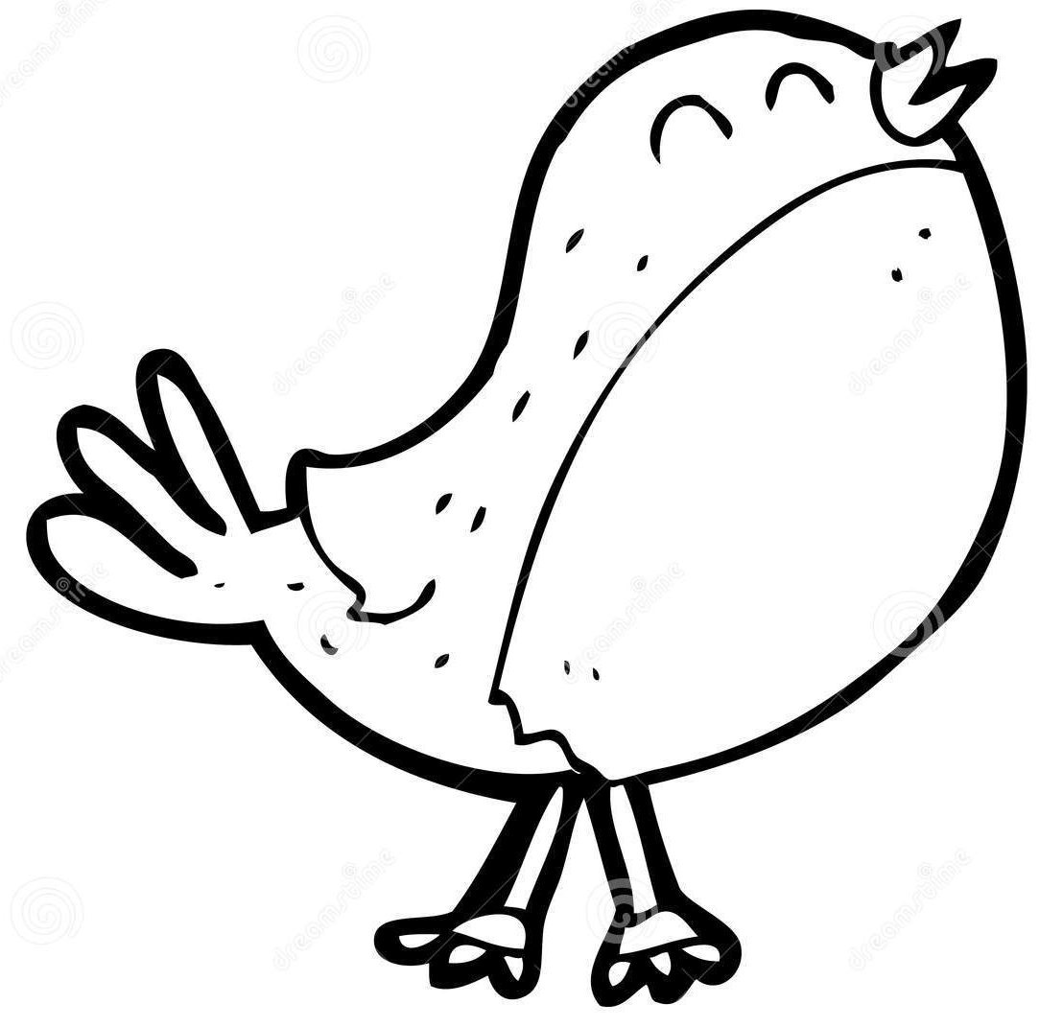
This term our topic in Robin Class is
Home Learning
- EdShed online spelling homework – practise daily
- Daily reading from reading book – minimum of four to be recorded in Reading Records every week.
- MyMaths activity
- TT Rockstars practise
Using books and websites, do some research for one or more of the Activity Grid. Your work needs to be handed in on the Monday of the final week before Easter (Monday 27th March).

‘Migrants’
Key Learning in Geography
Questions:
1: What is migration?
2: What causes people to migrate?
3: How does migration affect people and places?
4: What is the Windrush generation?

Other Key Learning
- PE: Netball/ Yoga
- French: Colours
- PSHE: Rights and Respect
- DT: Cooking and nutrition
- RE: Stones as symbols
- Music: ‘March’ from The Nutcracker
Class Books: Emmanuel’s Dream
Migrants by Issa Watanabe
Key Learning
English:
Text: Cinnamon by Neil Gaiman
Outcome: Own traditional tale
Text: A Walk in London by Salvatore Rubbino
Outcome: Report (Guided tour)

Reading:
Text: Malala Yousafzai - Fighting for Education by Nathan Sacks
Text: Book of Nature Poetry by Lewis and J. Patrick – Focus on range of reading skills: Prediction, Clarification, Questioning, Summarising, Inference, Critique
Maths:
- Factions: tenths, decimals, wholes, equivalent fractions
- Fractions: of a set of objects, of an amount
- Fractions: Comparing & ordering

Robin Class Trip
N/A

Key Learning in Science
Electricity:
- Common appliances that use electricity.
- Build and draw a series of circuits.
- Conductors and insulators.
- Conductivity within a circuit.

