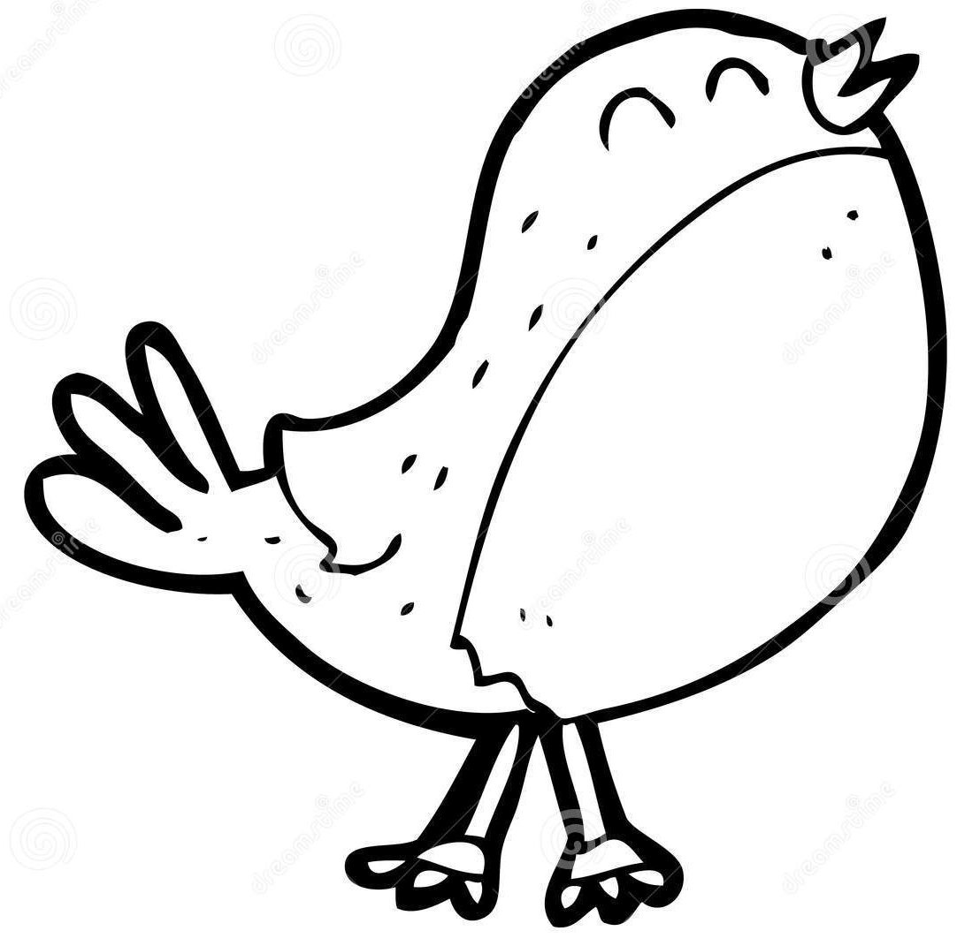
This term our topic in Robin Class is
Home Learning
- EdShed online spelling homework – practise daily
- Daily reading from reading book – minimum of four to be recorded in Reading Records every week.
- MyMaths activity or Maths homework sheet on class learning where relevant
- TT Rockstars practise
Using books and websites, do some research for one or more of the Activity Grid. Your work needs to be handed in on the Monday of the final week before the half term (10th February).

‘Anglo-Saxons’
Key Learning in History
Questions:
- How did control of Britain change after the Romans left?
- What was life like in Anglo Saxon Britain?
- Who ruled Anglo-Saxon Britain?
- What can written sources tell us about life in Anglo-Saxon Britain?
- Can you design an Anglo-Saxon burh?

Key Learning
English:
- The Lost Thing by Shuan Tan – Description

- The Street Beneath my Feet by Charlotte Guillain - Information text.
- Reading – the Magic Paintbrush -Focus on range of reading skills: Prediction, Clarification, Questioning, Summarising, Inference, Critique
- Spellings and Handwriting daily
Maths:
- Multiply and divide by 10 and 100.
- Multiply and divide up to three digit numbers.
- Measurement: Length and perimeter
Key Learning in Science
Sound:
- Identify how sounds are made, associating some of them with something vibrating
• Recognise that vibrations from sounds travel through a medium to the ear.

Robin Class Anglo-Saxon experience day
13th January 2024
Class Books: The Magic Paintbrush and My dad’s a birdman
Other Key Learning
- PE: cricket/ Ball Games
- Music: Singing
- French: Days and Months
- PSHE: Keeping myself safe.
- Art – drawing, growing artists.
- RE: Passover

