Understanding of the World
Children can describe an animal using some scientific vocabulary. Children have an understanding of some animal habitats and can describe them and who lives in them.
Children can use positional language and extend this to using a BeeBots or instructing a friend to move. Children recognise some environments are different to the one in which they live.
Children understand what curiosity is and importance of asking questions. Children find out about other countries and people through non-fiction texts, stories, visitors, celebrations.
Children make observations or find information about different locations and places. They recognise, know, and describe features of a studied location. Understand some changes in the natural world around them, including the seasons.
Children visually represent their own day on a simple timeline.

Literacy
Children will develop and secure their letter formation and will continue to improve their skills of segmenting and blending for reading and writing. Children will write their own name and captions and labels. They will begin to write phonetically plausible words and
re-read what they have written to check it makes sense.
Children will learn how to form capital and lower-case letters correctly and use capital letters and full stops.
They will begin to write simple sentences that can be read by themselves and others with some words spelt correctly.
Key texts this term include:
Lost and Found, Zog and the Flying Doctors, Here We Are, One Day on Our Blue Planet

Maths
Children will continue to develop their understanding of numbers up to 10. They will strengthen their ability to subitise (knowing how many objects there are without counting them.) Addition and subtraction, in its simplest form will be introduced as 1 more and 1 less. We will explore both mass and capacity comparing both. Additionally we will explore and compare length and height. We will talk about, order and sequence time. Finally, we will explore 3D shapes and patterns.

Personal, Social and Emotional Development (Self-Regulation, Managing Self, Building Relationships)
• Recognising different feelings (their own and others) and starting to find ways to manage them (e.g. tell a grown up when I am sad)
• Sharing and taking turns with toys more independently when playing, and learning to wait a while before we have a turn
• Managing self-care with greater independence – toileting, dressing (only needing help with small fastenings)
• Listening carefully to instructions from adults and following those with more than one step (e.g. get your P.E bag and find a chair to sit at)
• Understand and follow the school rules most of the time
• When carrying out activities / playing, keep on trying if something becomes tricky and know to ask an adult for help
• Play games with my friends and encourage others to join in
PHSE Focus
Keeping Safe

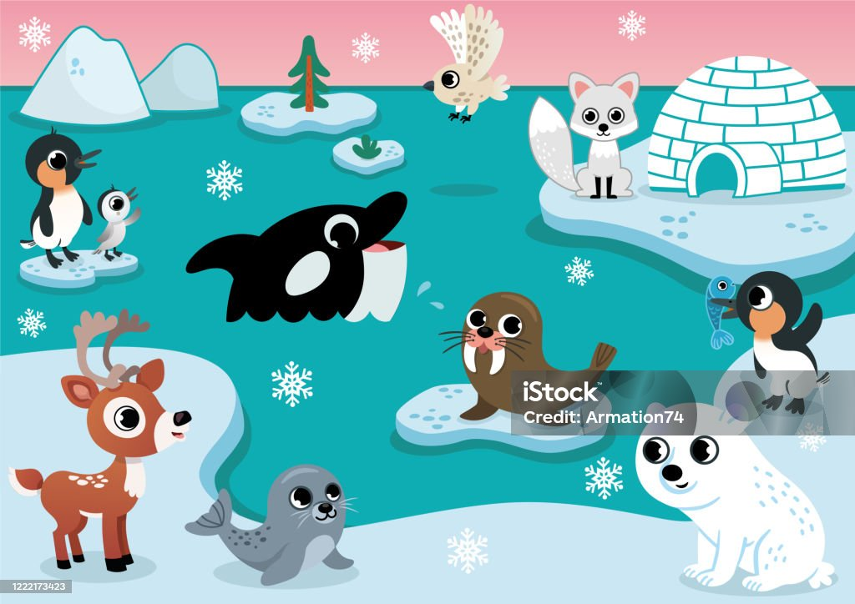
Expressive Arts and Design (Creating with Materials, Being Imaginative and Expressive)
• Build with different construction materials, starting to expand models by building horizontally and vertically
• Chooses and experiments with a range of media, materials and tools to create artwork using their own ideas
• Start to adapt their ideas whilst making / building (e.g use different construction material if model keeps breaking or falling down)
• Act out stories using pictures / props as prompts
• Act out experiences / take on roles when playing games or playing in role play area
• Uses instruments to copy and continue a simple rhythm / play along to a song
• Combines movements to express their feelings (move / dance in different ways to music)
• Talks about and responds to art (e.g this music sounds like the animals running through the jungle)

Physical (Fine and Gross Motor Skills)
• Move in a range of ways experimenting with body shape, position and speed
• Jump off objects with care, landing using arms to balance
• Shows good balance when playing on large playground equipment
• Changes speed when playing games to help move round space with more care, avoiding obstacles
• Shows more control when throwing, catching, and kicking
• Moves to music
• Handles tools carefully and with more control (e.g. starting to move paper when cutting to help cut round object more accurately)
• Begins to form letters mostly correctly, with correct pencil grip
• Begins to use anti-clockwise movement and retrace vertical lines when drawing / writing
• Knows some ways we can stay fit and healthy
Cricket coaching Tuesdays. Please come to school in a tracksuit and trainers.
Communication and Language
• Uses language and new vocabulary learnt to recreate roles and experiences in the role play area
• When talking to someone sticks to a main theme
• Can listen to and follow instructions with more than one step
• Can listen and do for a short period of time (e.g. listen to story whilst putting something in book bag at home time)
• Can follow / listen to a short story without pictures (e.g retelling of Traditional Tales.)
• When having a conversation with others (one to one or in a small group), respond to what others say to show they are listening / interested
• Understand questions such as who, what, where, when, why, how

