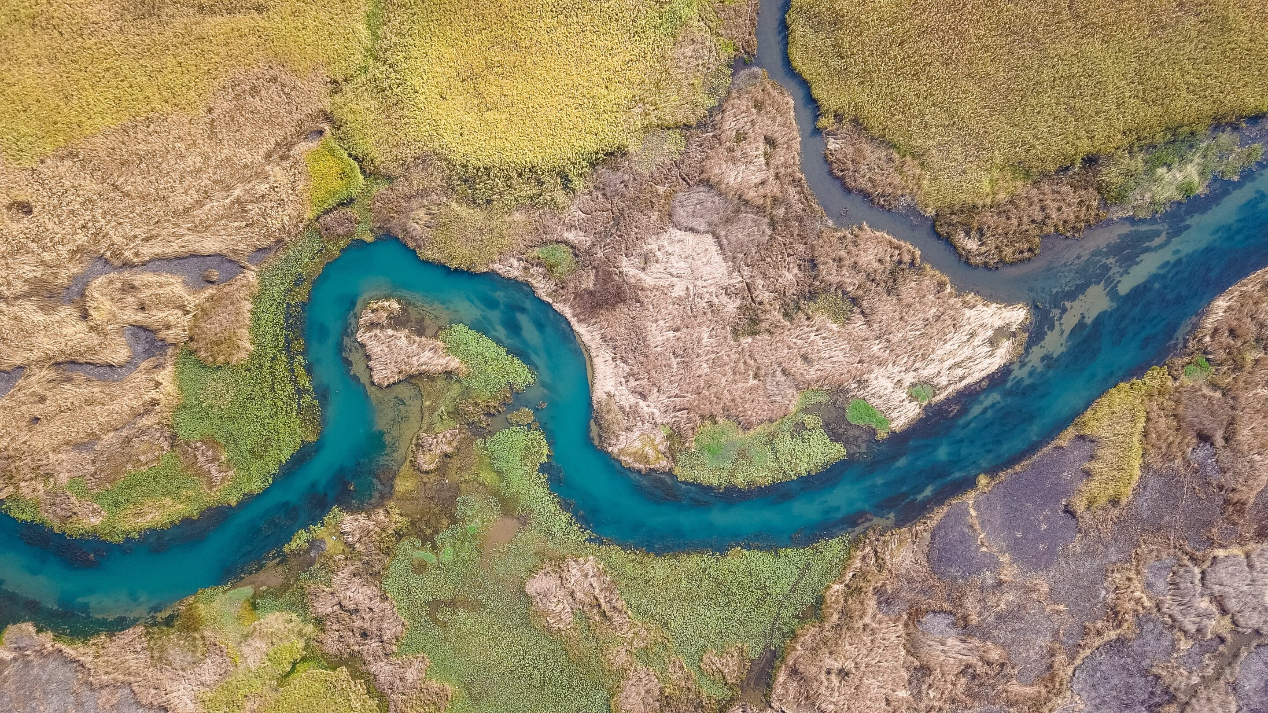
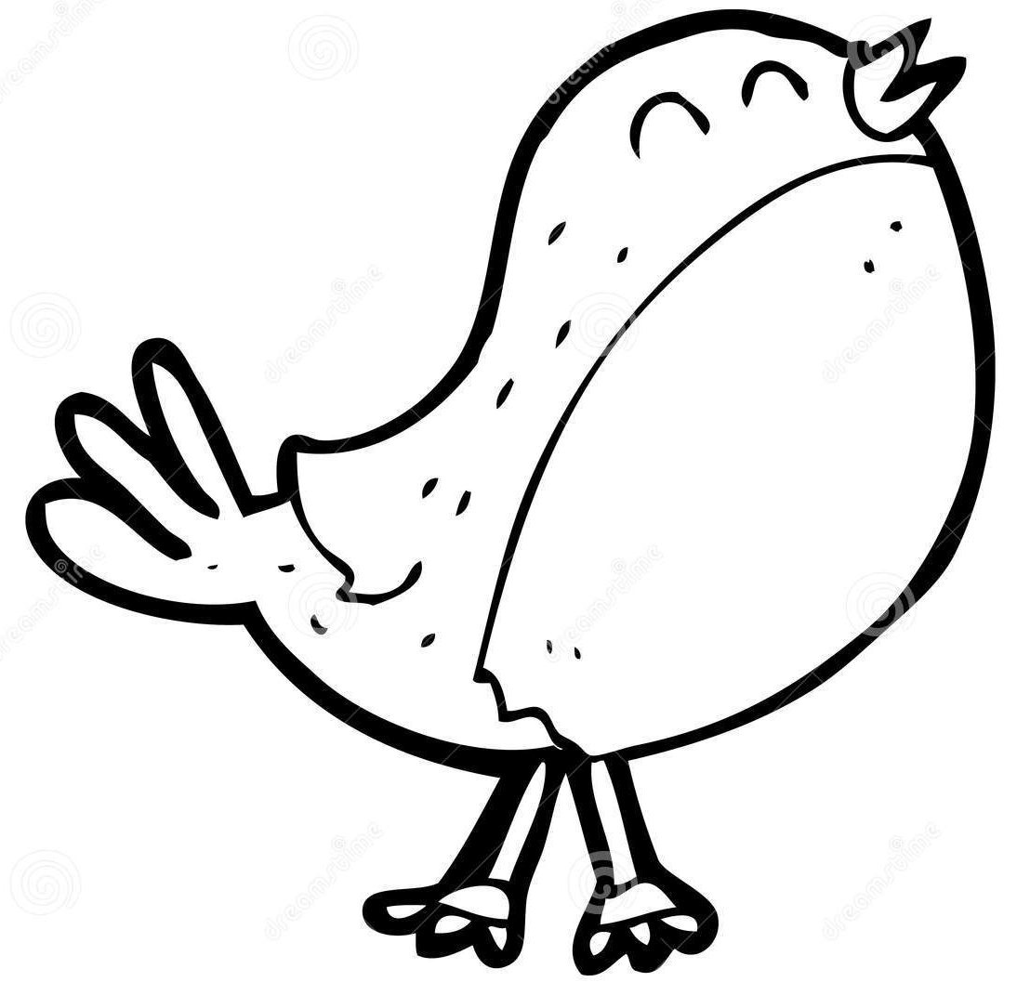
This term our topics in Robin Class are
Home Learning
- EdShed online spelling homework – practise daily
- Daily reading from reading book.
- MyMaths activity or Maths homework sheet on class learning where relevant
- TT Rockstars practise
Using books and websites, do some research for one or more of the Activity Grid. Your work needs to be handed in on the Monday of the final week before the half term (16th Dec).

‘Rivers’
Key Learning in Geography
Questions:
- What are the major rivers in the world?
- Why are rivers important to people?
- Why is the Volga River important?
- What are erosion, transportation and deposition?
- Why is it important to protect rivers from pollution?
Key Skills: Locate key rivers, use maps, analyse impact of humans

Key Learning
English:
- The Lost Words by Robert Macfarlane – create an autumn poem.
- Travel so Far by Laura Knowles – Non-Chronological info page.
- Ice Palace by Robert Swindells – Description of a snowy scene.
- Reading – Focus on range of reading skills: Prediction, Clarification,
- River story by Meredith Hooper (non-fiction).
- Questioning, Summarising, Inference, Critique
- Spellings and Handwriting daily
Maths:
- Multiplication and Division – 3s,4,6s,8s times tables (Year 4s: 7s, 9s, 11s,12s)
- Arrays, equal groups, division is the inverse of multiplication
Other Key Learning
- PE: Hockey & Dodgeball/Games
- Music: Singing
- French: Numbers
- PSHE: Health and Wellbeing
- DT: Digital world: Wearable technology
- RE: Symbol - Hanukkah
Key Learning in Science
Grouping and classifying living things:
- Recognise that living things can be grouped in different ways.
- Explore classification keys.
- Identify a variety of living things.
- Gather, record and data in different ways.

